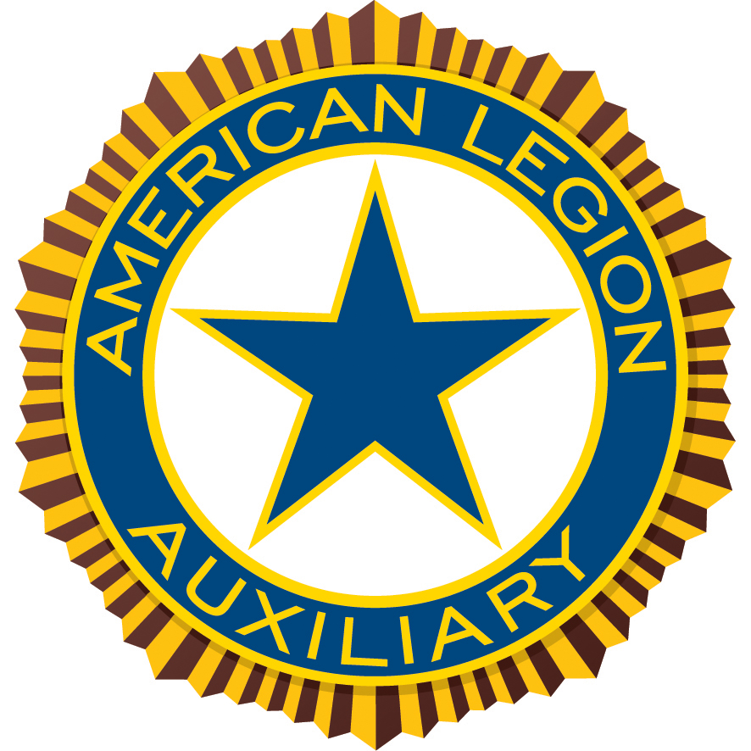

American Legion Auxiliary Department of [STATE]
Media Release
Street Address, City, State ZIP Code
www.ALAforVeterans.org (and your unit’s or ALA Girls State website, if available)
Contact: [PR Chairman], [PR Chairman’s Phone Number], [PR Chairman’s Email Address]

[DATE]
FOR IMMEDIATE RELEASE

Local Student Headed to American Legion Auxiliary Girls State,
Patriotism and Leadership Conference

[CITY, STATE]- [ATTENDEE’S NAME] of [HOMETOWN] has been selected to attend American Legion Auxiliary (ALA) [DEPARTMENT] Girls State. As part of the premier ALA program, [ATTENDEE’S LAST NAME] will study local, county, and state government processes during this [# OF DAYS] day nonpartisan political learning experience.

[ATTENDEE’S LAST NAME], a rising junior at [HIGH SCHOOL], was selected to attend ALA [DEPARTMENT] Girls State based on [selection criteria through Auxiliary unit and/or high school]. She also participates in many activities in her school and community, including [ACTIVITIES].

ALA Girls State attendees, known as “citizens,” receive special instruction in parliamentary procedure and organize themselves into two mock political parties. The young women then campaign, hold rallies, debate, and ultimately vote to elect city, county, and state officials. Once elected to office, delegates are sworn in and perform their prescribed duties. Attendees not elected to office are given appointments and visit the offices of those elected to share their viewpoints as citizens.

“QUOTE ABOUT THE PROGRAM AND WHAT IT TEACHES YOUTH,” said [NAME], ALA [DEPARTMENT] Girls State chairman. [LAST NAME OF CHAIRMAN] and other ALA volunteer leaders at the conference encourage the young citizens to continue their community service by becoming members of the American Legion Auxiliary, as well as leaders in their communities and local governments.

Every spring, approximately 25,000 young women across the country are selected to attend ALA Girls State programs in their respective states. Two outstanding citizens from each of the 50 ALA Girls State programs are then chosen to represent their state as “senators” at ALA Girls Nation held in Washington, D.C. in July.

The American Legion Auxiliary (ALA) is a community of volunteers serving veterans, military, and their families. Our members also support the mission of The American Legion in improving the quality of life for our nation’s veterans. Proud sponsor of ALA Girls Nation, National Poppy Day® and recognized for advocating for veterans on Capitol Hill, the more than 600,000 ALA members across the country volunteer millions of hours annually and raise millions of dollars in service to veterans, military, and their families. Founded in 1919, the ALA is one of the oldest patriotic membership organizations in the U.S.A. To learn more and to volunteer, join, and donate, visit www.ALAforVeterans.org.
###

